**Method 1**

**Step 1: Login in to the FTP server and open power shell.**

* cd C:\Program Files\Microsoft Data Protection Manager\DPM\bin>
* SetDPMServer.exe -dpmservername SPNIDCBACKUP.setindia.com -isnondomainserver - username (new username)
* Enter new password

**Verify in mabs console.**

**Method 2**

**Step 1: Stop the protection for the MSMWRLFTP server and note the folder path.**

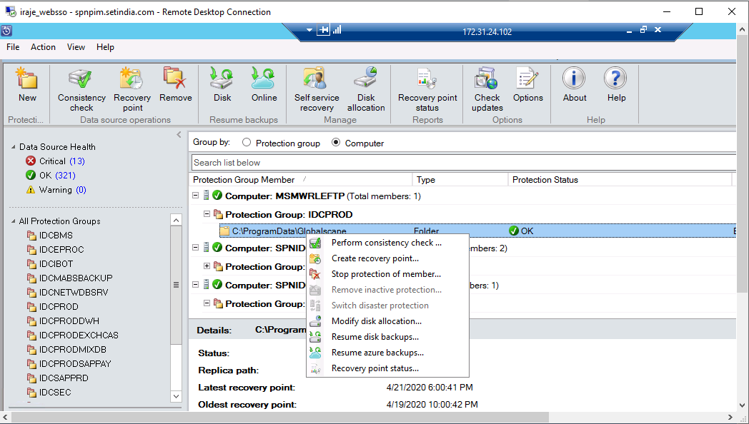

**Note: Don’t delete the existing backup(local and online backup)**

**Step 2 : Disable protection for MSMWRLFTP server in the management tab.**

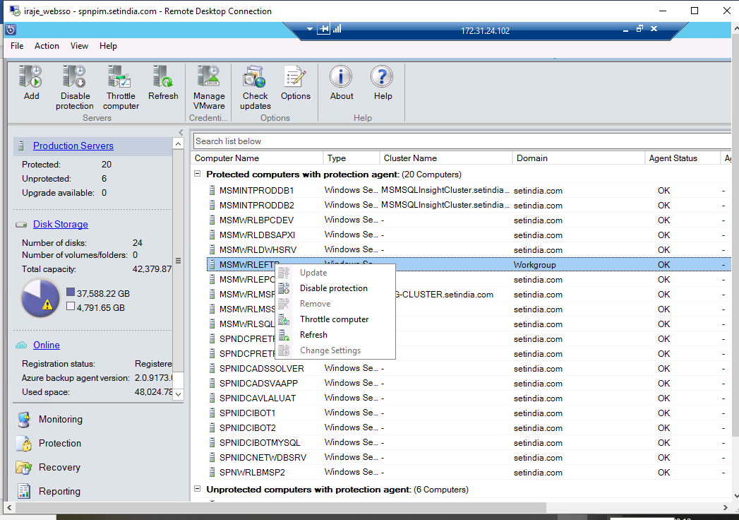

**Step 3:**

**Go to the protected server (FTP server)**

* **Uninstall the DPM agent**
* **Re install the DPM agent**

**Step 4:**

Open power shell and execute the below cmd to give new username and password

* cd C:\Program Files\Microsoft Data Protection Manager\DPM\bin>
* SetDPMServer.exe -dpmservername SPNIDCBACKUP.setindia.com -isnondomainserver - username (new username)
* Enter new password

**Note:** Give new username not the existing one

**Step 5:**

Click add and Attach the agent in the DPM server.

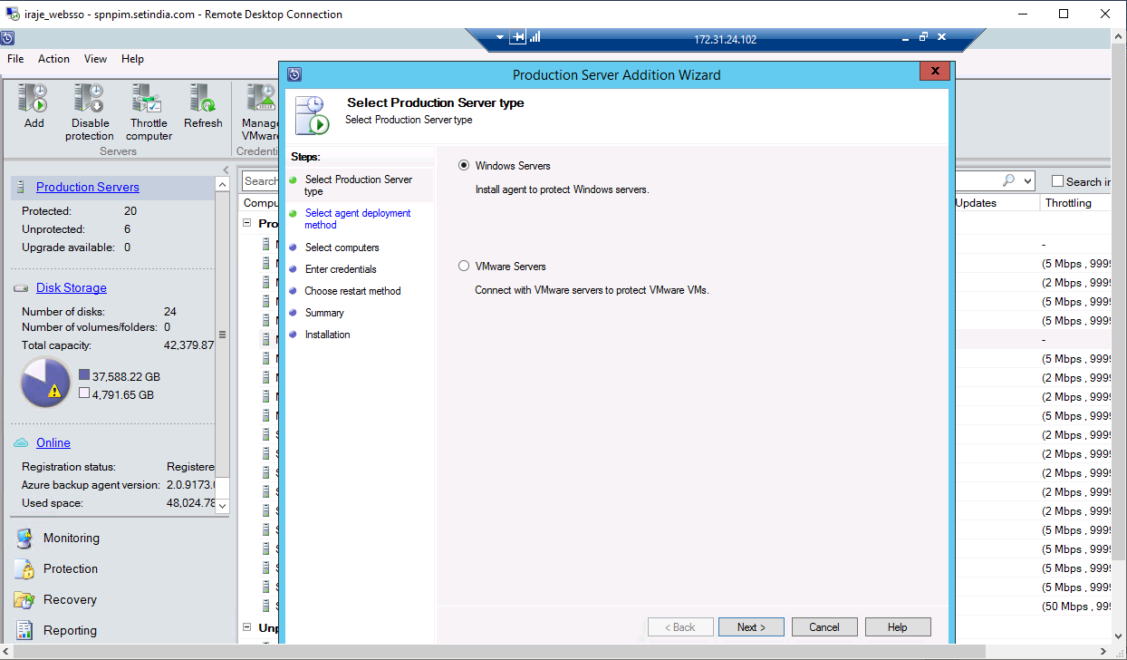

**Select attach agent and computer in a workgroup refer the below screen shot.**

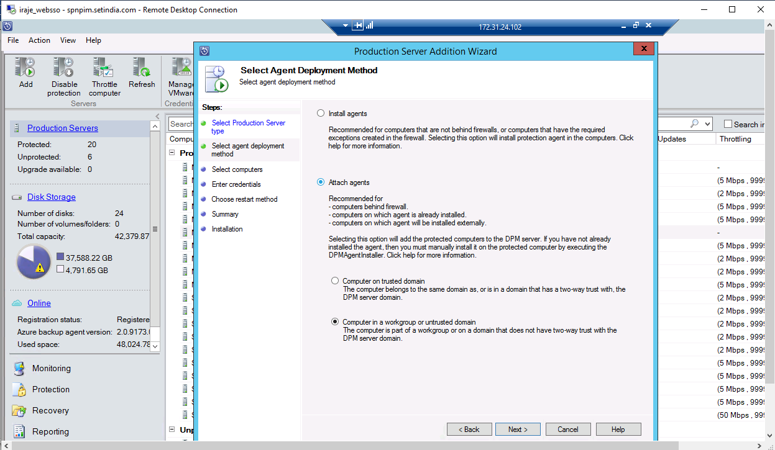

**Enter the server name, username and password (which you have given in ftp server step 4) -> add -> next . Verify in the management tab whether agent status is back to normal.**

